**New Purchasing House**

1. **New House Information:**

|  |  |
| --- | --- |
| **Property: Address:** | # 10, St. Tang Kasang, Sangkat Krang Thnung, Khan Porsenchey, Phnom Penh. |
| **Property Type:** | Flat House |
| **Front Road:** | 10m |
| **Land Size:** | 4m*18m=72sqm |
| **Building Size:** | 4m*16m=64sqm*3 floors=192sqm |
| **Title Deed No:** | N/A |
| **SPA:** | N/A |

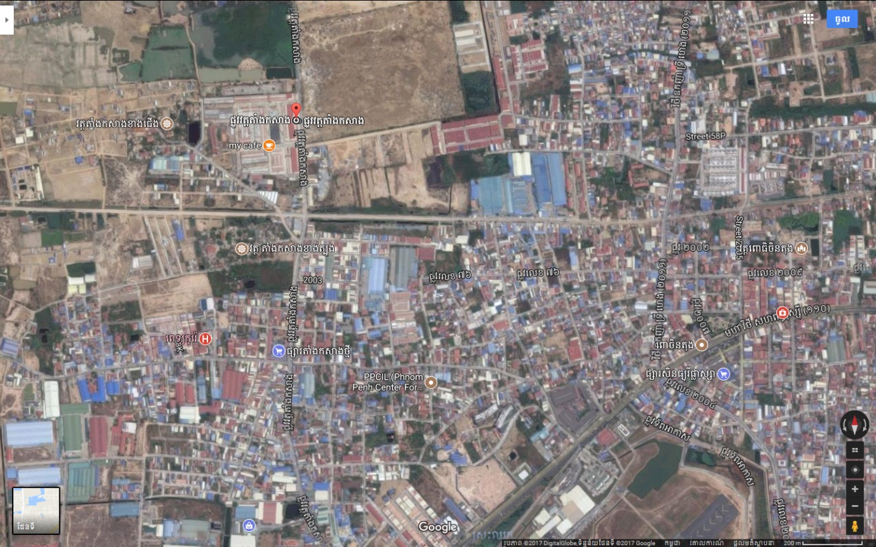

**Purchasing House**

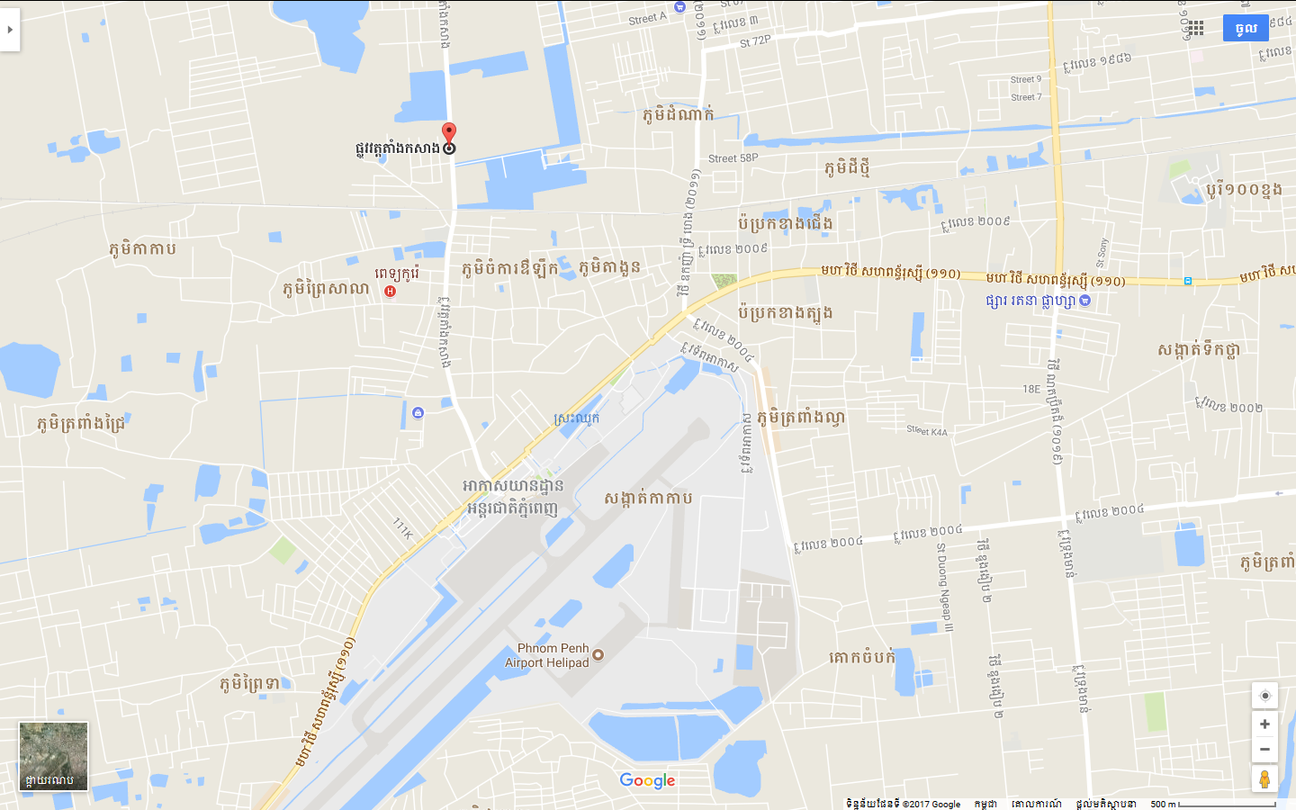

**Purchasing House**

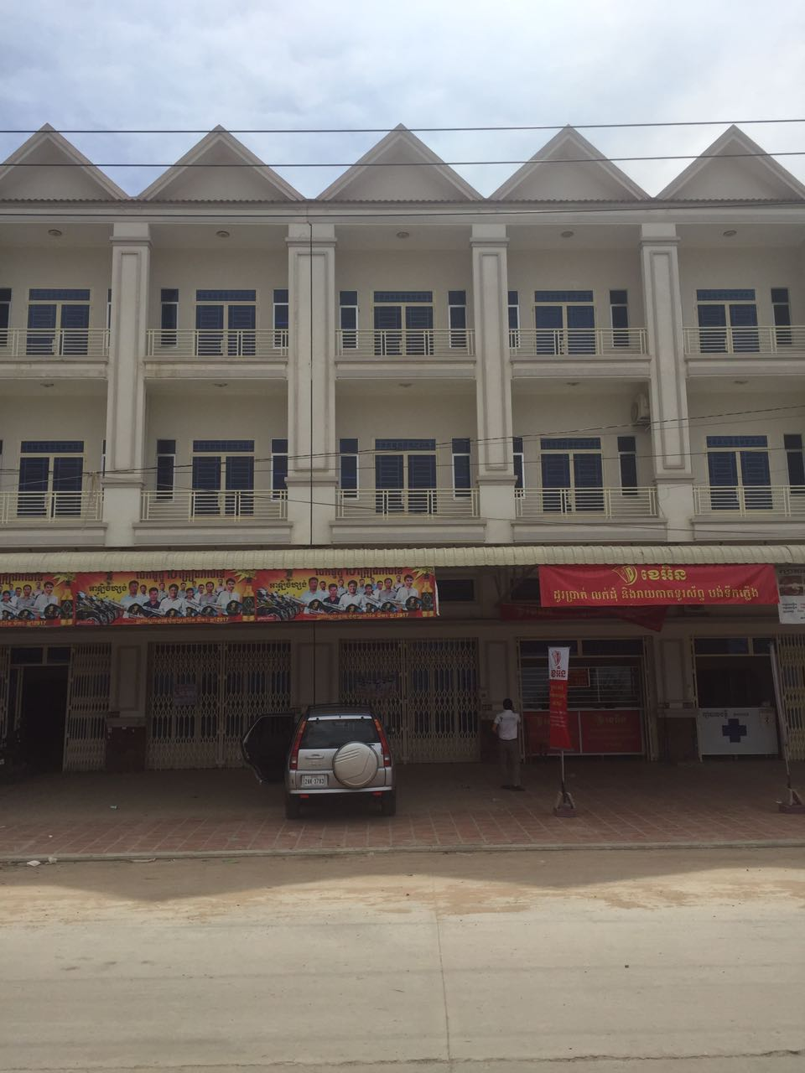

**Purchasing House**

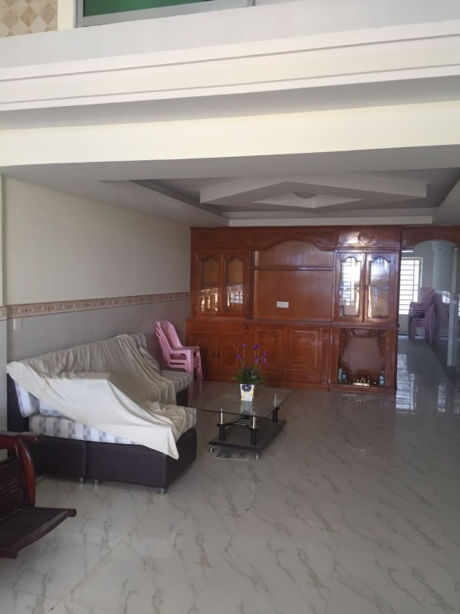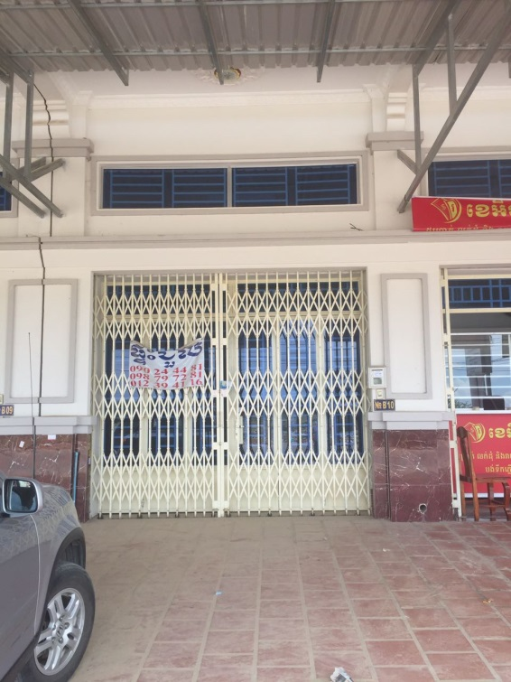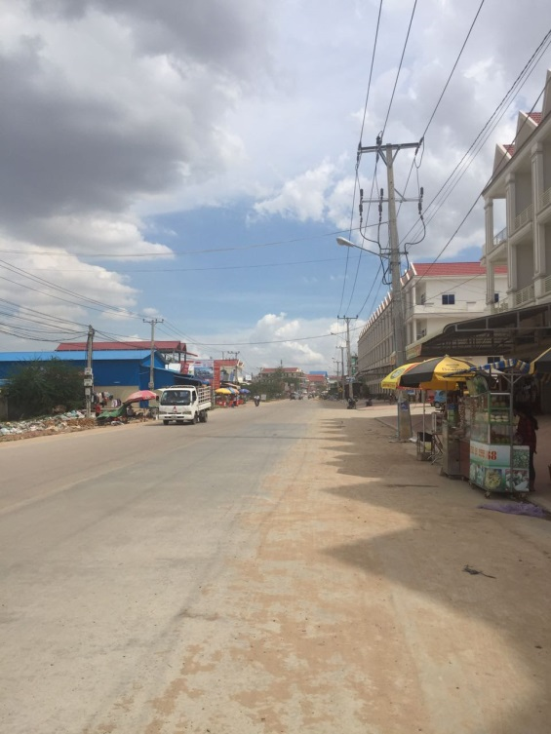

**Purchasing House**

**On right hand of purchasing house**

